**FC002B - Frequency Counter**

This is a simple low cost frequency counter can be used for frequency measurement or as frequency scale for various devices

***Specification:***

Supply Voltage: 3,3V

Maximum frequency: 16MHz (min. 20ns impulse width)

Display: 8 digit 7 Segment LED (Common Chatode Green)

Input level: 3.3V CMOS Logic

Time Base: 4.194304 MHz XTAL

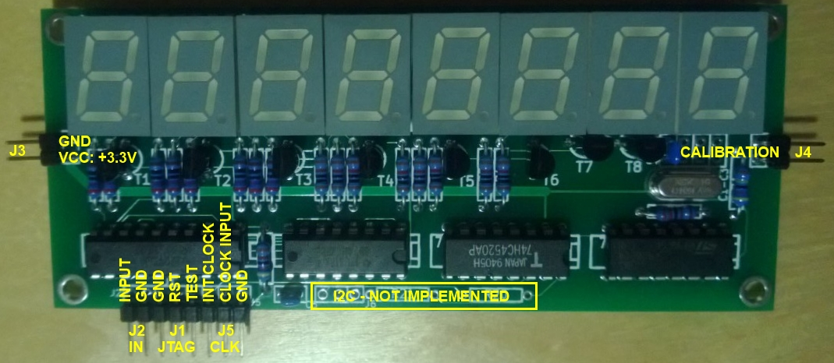

***Connectors:***

J1 – JTAG Programing connector (Texas Instrumments MSP430 Spy-By-Wire programming)

J2 – Signal Input (CMOS 3.3V Logic)

J3 – Power (Single 3.3V)

J4 – Calibration connector (Not used during normal operation. It can be used to connect few pF capacitance or trimmer cap during calibration to achive the precise XTAL frequency)

J5 – Clock connector. The INT CLOCK and the CLOCK INPUT pins must be shorted with a jumper during normal operation when internal clock source is used. If external clock source used it must be connected to the CLOCK INPUT and the GND pins.